Answers
1. An automatic door to an office building makes use of a microwave sensor to detect when people are near the door.
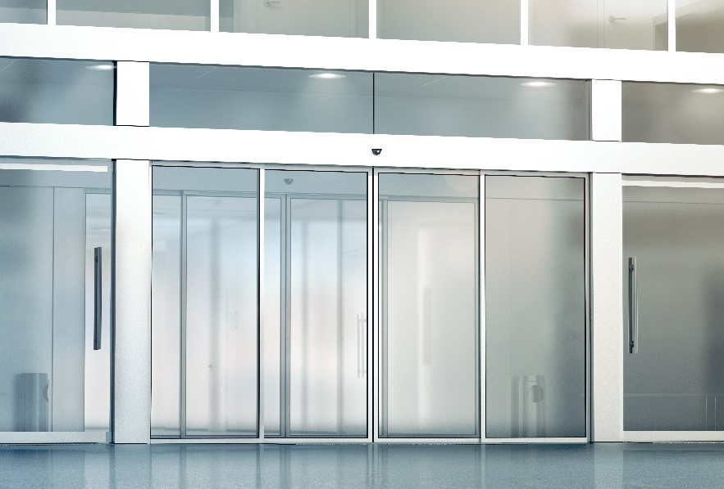

(a) State two other sensors. [2]
Any two from:
temperature sensor (1)
infra-red sensor (1)
push button (1)
GPS sensor (1)
smoke sensor (1)
pressure sensor (1)
Or any other sensor.
(b) State two other components that are needed for this automated system to work. [2]
microprocessor (1)
actuator(s) (1)

2. An ice cream factory makes use of an automated system to fill ice cream tubs.
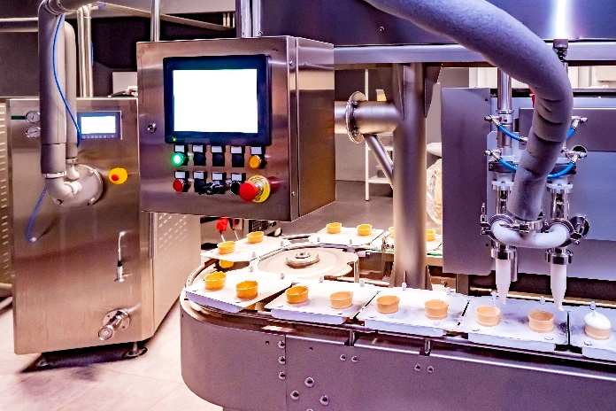
(a) Describe how this automated system works. [4]
Tubs are moved around on a conveyor belt (1) which is controlled by motors/actuators (1).
Sensors detect when the tubs are in the correct location (1) a microprocessor processes the sensor’s input data (1).
At the correct point, actuators (1) release the correct amount of ice cream into the tubs (1).
Push buttons are used to stop the machine / change its operation. (1)
Or any other reasonable description of how the system works based on the photograph shown.
(b) Suggest two advantages of using an automated system in the ice cream factory. [2]
more efficient than a person (1)
more accurate than a person (1)
works 24 hours a day / doesn’t need a break (1)
can work in areas of the factory that are dangerous (1)
reduces running costs / wages / overheads (1)
consistent results / output (1)
(c) Suggest two disadvantages of using an automated system in the ice cream factory. [2]
there is a large initial cost to purchase/install the machinery (1)
people may lose their jobs as a result of the automation (1)
there may be a reduced number of jobs available for people (1)
if the machinery is incorrectly programmed / set up it may be dangerous (1)

[Total 12 marks]

